A000-EUR-Latvia-Figurine Pendant-Female-Amber-Neolithic-5500 BCE

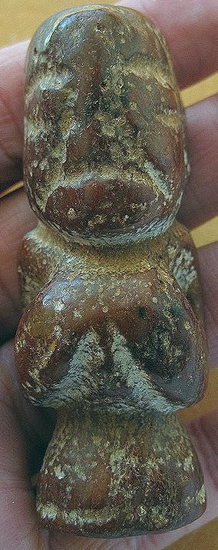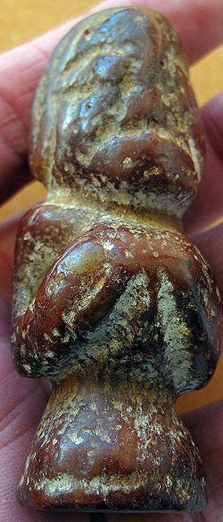 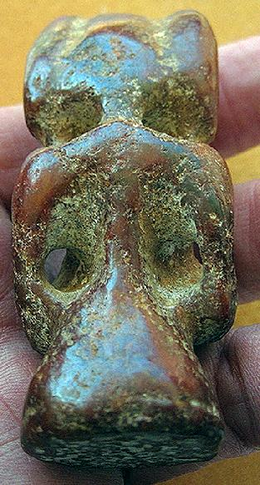

Formal Label: EUR-Latvia-Figurine Pendant-Female-Amber-Neolithic-5500 BCE

Accession Number:

Display Description:

Baltic region forests created more than 100,000 tons of amber or succinite 44 mya during the Eocene epoch (Ritzkowski 1997). This figurine dates to the Neolithic period.

**LC Classification:** GN774.22.E853

Date or Time Horizon: 5500 BCE

Geographical Area: Latvia

Cultural Affiliation: Neolithic

Medium: amber

Dimensions: H 3 in

Weight:

Condition: original

Provenance: Latvia

**Discussion:**

**References:**

Gimbutas, M., 1974. *The gods and goddesses of Old Europe: 7000 to 3500 BC myths, legends and cult images* (Vol. 4). Los Angeles: Univ of California Press.

Riede, Felix and Miikka Tallavaara. 2014. *Late glacial and postglacial pioneers in Northern Europe.* Oxford: Archaeo Press

Ritzkowski, S. (1997). "K-Ar-Altersbestimmungen der Bernsteinführenden Sedimente des Samlandes (Paläogen, Bezirk Kaliningrad)". *Metalla. Bochum*. 66 (Sonderheft): 19–23.